Software Requirements
Specification
for
E-Tech Website using Django
Version 1.0

10-Jan-2024

Table of Contents

Table of Contents Revision History
- Introduction
  - Purpose
  - Intended Audience and Reading Suggestions
  - Product Scope
  - References

Overall Description
  - Product Perspective
  - Product Functions
  - User Classes and Characteristics
  - Operating Environment
  - Design and Implementation Constraints
  - Assumptions and Dependencies

External Interface Requirements
  - User Interfaces
  - Software Interfaces
  - Communications Interfaces

Analysis Models
  - Customer Use case diagram
  - Seller Use case diagram
  - ER diagram.

System Features
  - User Accounts
  - The search facility
  - Shopping cart facility
  - Payment
  - Order and returns
  - Other system features
  - Seller features

Other Nonfunctional Requirements
  - Performance Requirements
  - Safety Requirements
  - Security Requirements
  - Software Quality Attributes
  - Business Rules

Other Requirements Appendix A: Glossary Appendix B: Field Layouts
Appendix C: Requirement Traceability matrix

Document Approval

Signature | Printed name | Title | Date

Revision History

Date | Description | Author | Comments

- Introduction

Purpose
The purpose of this software requirement specification is to provide a clear, documented model of the requirements for the online shopping system. This document serves to provide top level use cases for a web customer making purchases online. The system includes the client subsystem as well the seller subsystem.
The online shopping system provides a platform for conducting sales of a wide variety of goods across the globe. It is implemented as an internet-based enterprise and has a vast inventory of products from books, houseware, electronics, groceries and much more.
Sellers use this system to easily expand their service to a more global platform. This guarantees better flexibility, larger audience and an improved market.
The appeal of online shopping systems experienced a large boost in the last decade because the customers can browse easily through various options, brands and price ranges with very little hassle. The ability to reap its benefits from the comfort of one’s own home has only bolstered its claim as one of the biggest enterprises that dominates the internet.

Intended Audience
The document describes the scope, functionality and features of an online shopping system which has a large audience. This document finds relevance to people from various different technical and non-technical backgrounds. The document outlines various corporate goals, business strategies and design features that are important from a management point of view and can be used by project managers. It analyzes performance, visibility and brand awareness which is important for marketing and advertising. With detailed analysis of the system design, features, implementation and performance, the document proves highly valuable to developers and testers.
Through the rest of the document, one becomes familiarized with the scope of these online shopping systems- from their purpose, benefits and business strategies. The context and origin of the product as well as its basic functionality are then explained in relevant detail along with an analysis of its different classes, design and implementation. We then detail the interface requirements, build analysis models and examine system features and non functional requirements.

Product Scope
The online shopping system provides a platform for conducting sales of a wide variety of goods and provides a way of bringing sellers and customers on an online platform to conduct transactions in a secure manner across the globe. It is implemented as an online enterprise. This system provides an avenue for customers to shop from a wide variety of products online. It also provides sellers a platform where they can upload their listing to the system for customers to view and purchase. The biggest advantages of the service is the comfort it brings with remote usage. The ability to compare various price ranges, brands and even customer reviews and experiences provides for a more honest/depthful understanding of the product. It also provides a platform for retailers and sellers to reach a global audience.

Fitted with recommendation models to analyze customer interests, previous purchases and ratings can help recommend other products that the customer may like. This model is essential to increase visibility of useful products to the customer but also to boost the service’s revenue. The service also has a large database that stores customer data and history. Another important benefit provided by the service is the reviews section. The reviews section offers transparency around product performance and user experience. Not only do items have ratings given to it by users, but also detailed user reviews with an option to attach pictures of the product. This feature boosts customer trust and creates a community of customers who can engage with each other and help one another select the right products. A key feature is secure money transaction along with guaranteed and time bound product delivery.
Increasing sales is of the highest priority to the online shopping system. Turnover can increase only with an increase in sales. Various strategies need to be tested to find suitable growth strategies for the business. Minimizing management costs, customer loyalty and retention and customer satisfaction are essential corporate goals that are important to boost sales. A huge part of the business strategy is using the internet and its various resources to its advantage from technological innovation, marketing strategy and business model. Continuous and adaptive research and development with a focus on logistics is essential for business growth. Besides M&A, investments and strategic partnerships, another way to expand business is to invest in emerging markets and new businesses. The vision of the online shopping system is to be able to provide a smooth and user friendly platform for customers to select from a wide range of products conveniently and to cater to the needs of both customers and sellers.

References
- Software Requirements Specification (SRS) Book E-Commerce System (BECS):
Authors: Andrew Blossom, Derek Gebhard, Steven Emelander, Robert Meyer
- Case Study: Flipkart online Author: Aman Goel Date: Nov, 2017
- 10 Problems That Every Ecommerce Business Faces and Their Solutions [Updated 2020]: Author: Laduram Vishnoi
Date: December 14, 2020
- A Study on Performance Measurement of Online Retail Stores: Authors: Binod Kumar Singh, Neeraj Anand
Date: March 2014
- Amazon.com Inc.’s Mission Statement & Vision Statement (An Analysis) Author: Lawrence Gregory
Date: February 13, 2019

Overall Description

Product Perspective
The system includes the user subsystem as well the seller subsystem. The online shopping system provides an outstanding way of bringing sellers and customers on an online platform to sell and make purchases in an efficient and secure manner irrespective of the distance between the two. It is a platform for customers to shop items online without having to visit a store or meet a seller physically, and a platform for vendors to sell their items online without having to meet the customers physically or have a physical store set up for his products. This system is a one stop for customers to shop from millions of products online. The seller uploads his listing to the system and the customers browse from these items and purchase them.
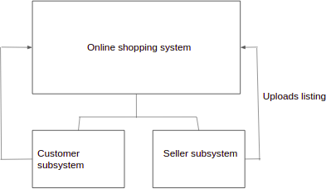

Product Functions
Enlisted below are all the major functions supported by the online shopping system along with the user classes.
- Register: for customers and sellers
- Login: for customers and sellers
- Logout: for customers
- View Account Details: for customers and sellers
- Edit Account Details: for customers and sellers
- Search item: for customers
- View item: for customers
- Add item to cart: for customers
- View shopping cart: for customers
- Change items in cart: for customers
- Proceed to buy: for customers
- Delivery & payment: for customers
- Place order: for customers
- Track order: for customers
- Cancel order: for customers
- Return item: for customers
- View orders and returns: for customers

- Rate item: for customers
- Review item: for customers
- Recommendations: for customers
- View sales: for sellers
- Deliver items: for sellers
- Upload listings: for sellers

User Classes and Characteristics
Customer - He/she is a verified user of the system who is intended to buy a product sold by a seller using the platform. The functions used by customer are register, view account, login, browse item, view item, buy item now, add to cart, view cart, proceed to buy, enter delivery address, enter mode of payment, make payment, place order, view orders, track package, write review, cancel order, return item, logout
Seller - He/she is a verified user of the product who is intended to sell items over the platform. The product functions used by sellers are register, view account, login, upload listing, your sales, deliver the items to customers.

Operating Environment
There are two modes of using the software - mobile applications and web applications. Mobile apps can be run on any android, iOS versions. Web applications can be run on Windows 10: Google Chrome (78 and later); Mozilla Firefox (70 and later); Internet Explorer (11 and later); Microsoft Edge (18.18362 and later), Mac OS X: Apple Safari (13.0.1 and later). The Internet is a basic necessity for the system to be accessed.

Design and Implementation Constraints

For ease of maintenance, the customer will only be able to make payments once items have been added to cart. There is no option to proceed directly to checkout with an empty cart. Brand specific agendas have been excluded from our design. Section showing deals of the day, gifting options and sales have not been included in the design. The wish list option has been merged with the cart as it serves very identical purposes. In an effort to build a community of customers, many sites had experimented with creating friendship communities on shopping platforms however, due to the transparency into costs of products, revealing personal expenditures to people- even within friendship communities could be seen as too transparent and even a breach of user data protection. This puts a limitation to developers. As these systems lean heavily on the ability to make real -time updates, the servers must be capable of handling sufficiently high traffic bursts, which may not always be the case. Logistically, most companies outsource their tasks to a third party organization which costs them more control over their implementation. Due to interfaces with payment methods like google pay or PayPal, the risk for middle attacks is often higher and may require additional safety at payment gateways. The recommendation system is assumed to be a server side feature. Our system is also partial to the needs of the customer more than it is to the seller. Customer functionalities have been more elaborately designed than Seller functionalities.

Assumptions and Dependencies
Under the assumption that a Windows/iOS/ Linux based operating system is available with C++/Python working along with database management software available, designing a modular view of the system is smooth. For a basic tool we are also assuming that only one customer may place an order at a given time, but will attempt to expand the scope. The recommendation models are assumed to be dependent on the server and its functionalities though relevant to customers will be more clearly defined by the server.

External Interface Requirements

User Interfaces

-> Home Page:
- The home page of this online shopping system is designed to be attractive and user friendly.
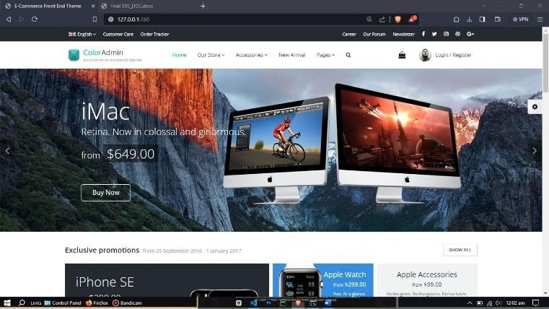
- It includes - search bar, buttons like Sign in, Cart, Returns & Orders Toda, User’s Customer Service, Buy Again, New arrivals,
Browsing History, Our pages, Change Language Option, Delivery Address and All Options & Categories.
- It also displays the top selling products in some of the popular categories like electronics, clothing, skin care etc. It advertises the current sales, discounts and offers.

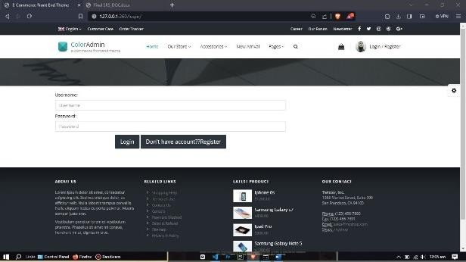

navigation bar.

-> Sign in:
  - This page allows the users with an fromaccount under this online shopping system to Sign in to their account. The user can Sign in either with their phone number or email id.
  - The user, after entering their username can click on the continue button. If the entered username is valid, the system asks the user to enter the password which if entered correctly, takes the user to the homepage of the system and the user name is displayed on the top

  - If the entered username is wrong, the system displays an error message saying ‘Incorrect email id (or phone number)’ and ‘We can not find an account with that( username)’.
  - If the username entered by the user is valid and the password entered is invalid, then the system displays an error message saying ‘There was a problem’ and ‘Your password is incorrect’.

  - There are also some other fields like ‘Don’t have account button’ to bring user to the sign up page

-> Create Account:
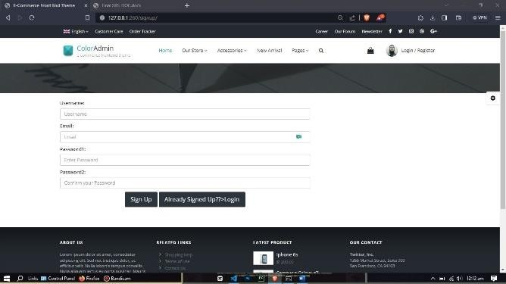
- This page allows users to create a new account. The user is asked to provide their Name, Email id and password. The constraint on the password field is that the password must contain at least 6 characters.
- The user is also asked to re-enter the password after which the user can createa new account by clicking on the ‘signup button’
- This page also provides other fields like ‘Conditions of Use’, ‘Privacy Notice’ and ‘Help’ which takes the user to appropriate pages.
- There is a sign-in field on this page for the users who already have an account.
The user shall be taken to the sign in page after clicking on it.

-> Buying item & Payment:

- During the checkout process, users will be presented with a summary of their order. This order summary includes a detailed breakdown of the selected items, their respective quantities, individual prices, the overall subtotal, any applicable shipping fees, and the total amount to be paid.
- Users might have the option to apply valid promo codes or discounts at this stage, allowing them to benefit from ongoing offers or promotions.

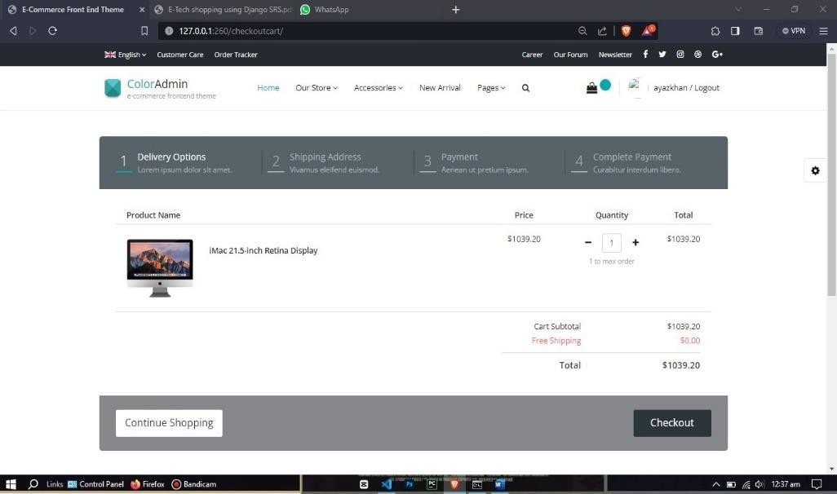

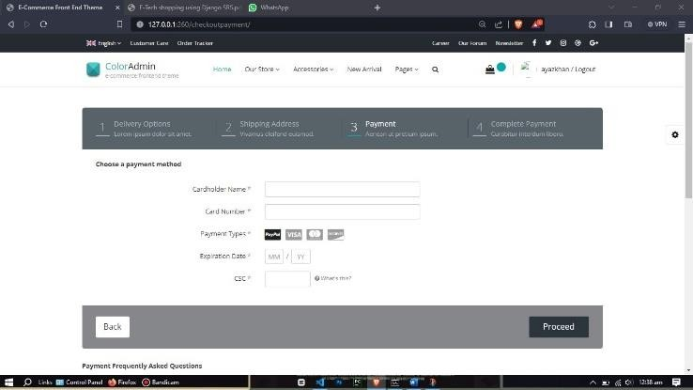
- Users will be prompted to provide payment information, typically including credit/debit card details such as the card number, expiration date, security code (CVV), and cardholder name. This information is crucial for secure transaction processing and authorization of the payment
- Additionally, users are required to input accurate billing details, which encompass the user's name, billing address, and contact information. This information helps in payment verification and ensures successful processing..

-> Cart:
- This page allows the user to save the items they wish to buy in the cart. It provides information about all the items added to the cart by the user. For each item in the cart functionalities like ‘Delete’, ‘Save for later’ and ‘Compare with similar items’ are provided to the user.
- The user can select all the items they wish to buy from the cart by clicking the checkbox next to each item. The user can then select the ‘Proceed to check out’ button to proceed with purchasing the item(s).

-> User’s Front page:
- This page provides the user some information about their activities in the online shopping system. This includes fields like ‘Your Browsing History’, ‘Your profile’, ‘Recommended for you’, ‘Improve your recommendations’.
- ‘Your Browsing History’ field provides the user with the information about the items they have searched.
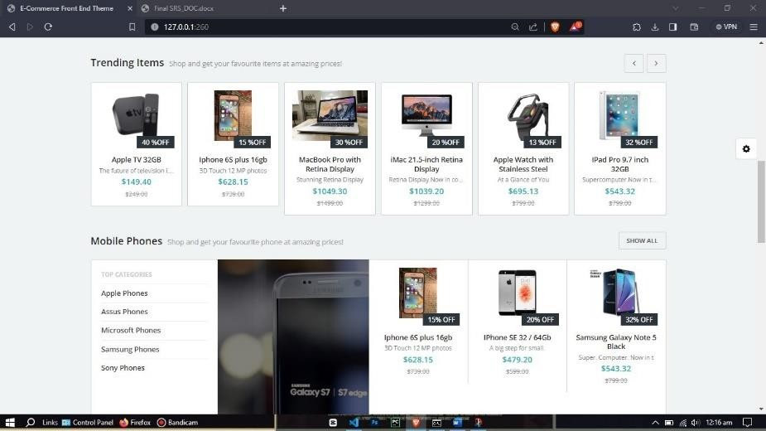
- The ‘Trending items for you’ section lets the user find new products that may interest them. Based on the Trends of the other user’s orders and their evaluations, new products that may interest them will be recommended. Also, their tastes will be compared with those of other clients in order to suggest certain products.
- The ‘Improve your recommendations’ section allows the user to refine their product recommendations. The user can rate their top product picks to refine
their recommendations. If the user does not want their recommendations to be based on a particular product, they can check the box against that product and select the option ‘Don't use for recommendations’.
- The ‘Your Profile’ field is where the user can share information about themself, their personal tastes, and opinions regarding various products and services. This is optional as they can choose between ‘Submit’ and ‘Not now’ buttons. If the user chooses to submit,

then this page will be open to the public. By default, it will not disclose any personal account information other than the user name of the user.

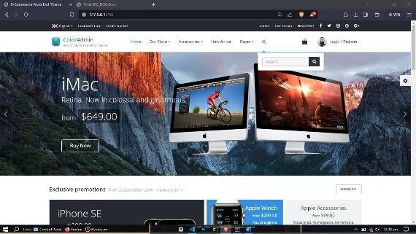
-> Search Bar:
- The users can use the Search Bar to conduct a Product Search and find the products they seek quickly and easily. It is present in the top navigation bar making the customer’s search the main focus of the online shopping system.

-> Change Language Option:
- This allows the user to select the language they prefer for browsing, shopping, and communications.
- The user can select their preferred language and click on save changes button.

-> User Account and Lists Field:
- This field provides the users with various functionalities and account details like ‘Your Orders’, ‘Your payments’, ‘Login and security’, ’Recommendations’ etc.

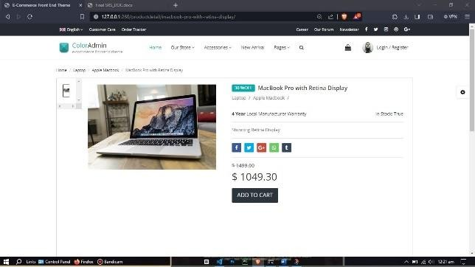
-> Options and Categories Field:
- This section displays various categories of products from which the user can shop.
- This section also provides various programs and features of this online shopping system.
- Here is also provided with various help and settings options for the convenience of the users.

-> Product Details Page:
- The users while searching for products, can click on them to view the complete information about the products.
- This usually includes one or more images of the product, product’s name, features, price, brand that is selling it etc.
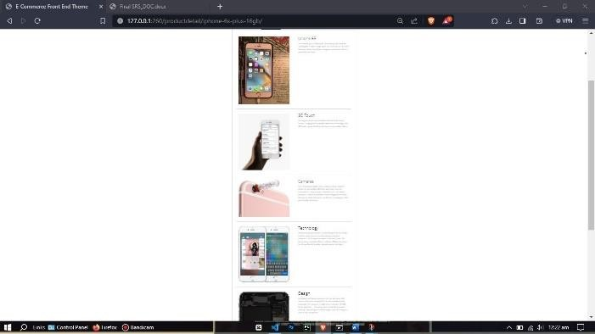
- The user after viewing the product details can then add the product to cart or buy it by clicking on the ‘Add to cart’ or ‘Buy now’ buttons respectively.
- By clicking on the ‘Buy now’ button, the user will
be asked to select a payment method and click on the ‘Continue’ button to proceed with placing the order.
- The user is provided with the billing details of the product. Then, the user can also review the order, edit the delivery address and click on ‘Place your order’ button to complete placing the order.
- The user will get a message to their phone number about their order once their order is placed.

Software Interfaces
- All the web pages of this online shopping system are majorly built using development tools like HTML, CSS, JavaScript, Bootstrap, Django, Python etc.
- This online shopping system is accessible through the internet on any Operating System like Unix, Linux, Mac, Windows, etc.
- This system stores the product data, customer data and seller data in multiple databases which are present in data centres located at various geographical locations. The types of databases mainly include Oracle database, , SQL Lite etc.
- The online shopping system shall communicate with the content manager to get the product specifications to the users in the Product Specification page.
- The complete information about the products is stored in the databases of the system. The content manager gets various information about the product like the images of the product, product’s name, features, price, brand that is selling it, product reviews, product ratings etc which is displayed to the users.
- The system shall communicate with the bill-paying system to identify the available payment methods, validate the payments and process them. The data which includes customer email id/ phone number, selected bill payment method, product id of the products selected to be purchased, their quantities, prices and payment details like (Card number, Name on the card, Expiration date etc) are shared with the bill-payment system.
- The system shall communicate with the credit management system for handling financing options. Data which includes the total price, payment method and payment details are shared with the credit management system.

- The system shall communicate with the Sales system for order management. The orders placed by the customers are managed by the Sales system based on the order details, the date & time when the order was placed, delivery address of the product(s) and approximate delivery date.
- The system shall communicate with the shipping system for tracking orders and updating of shipping methods. Once the order is placed, the shipping system is responsible for updating the users about the shipping process of the products they ordered. The updates are provided to the customers by sending messages to their phone number and email id about the shipping process.

Communications Interfaces
- The user can access the online shopping system through the internet by searching the system’s name on the web browser.
- The system shall use the HTTP protocol for communication over the internet.
- The system shall give confirmation to the customer that their order is placed by sending a message to the customer’s email id and phone number.
- The system also provides follow up messages to the customer’s phone number and email id to update the customer about the shipping process like ‘product is dispatched from the site’, ‘product shall arrive in 2 days’ etc.

Analysis Models

  - CUSTOMER USE CASE DIAGRAM:
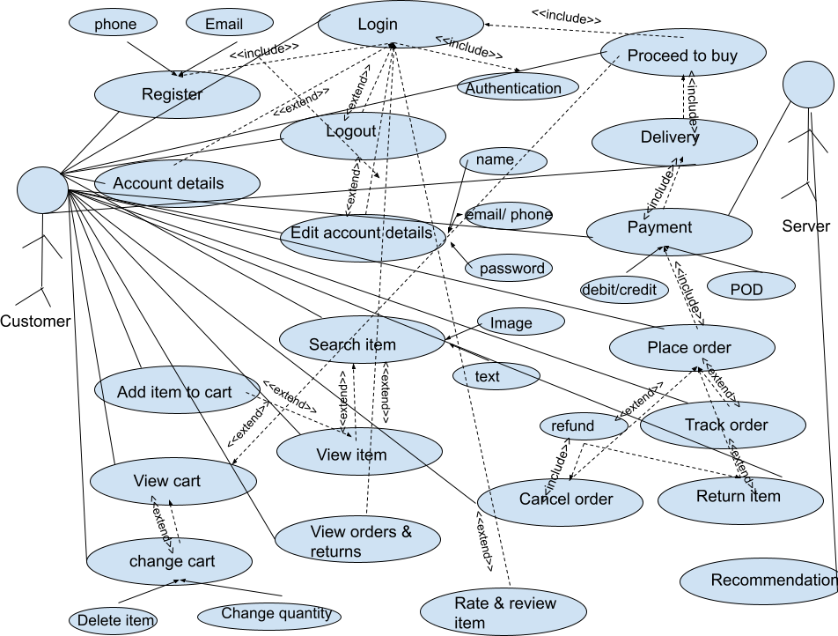

  - SELLER USE CASE DIAGRAM:
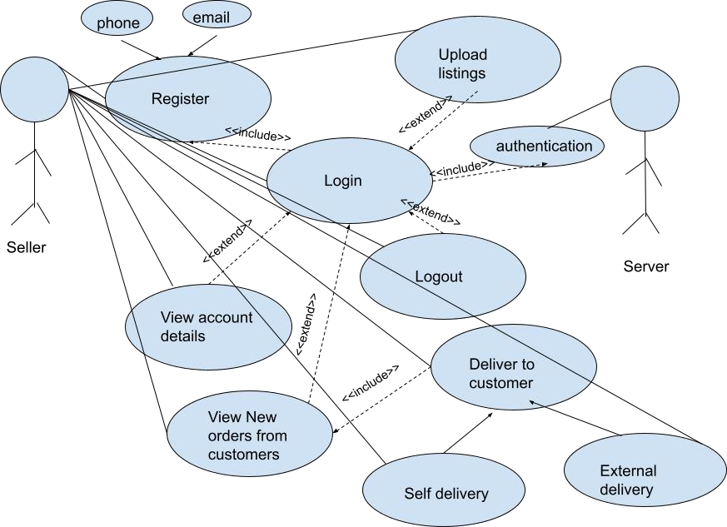

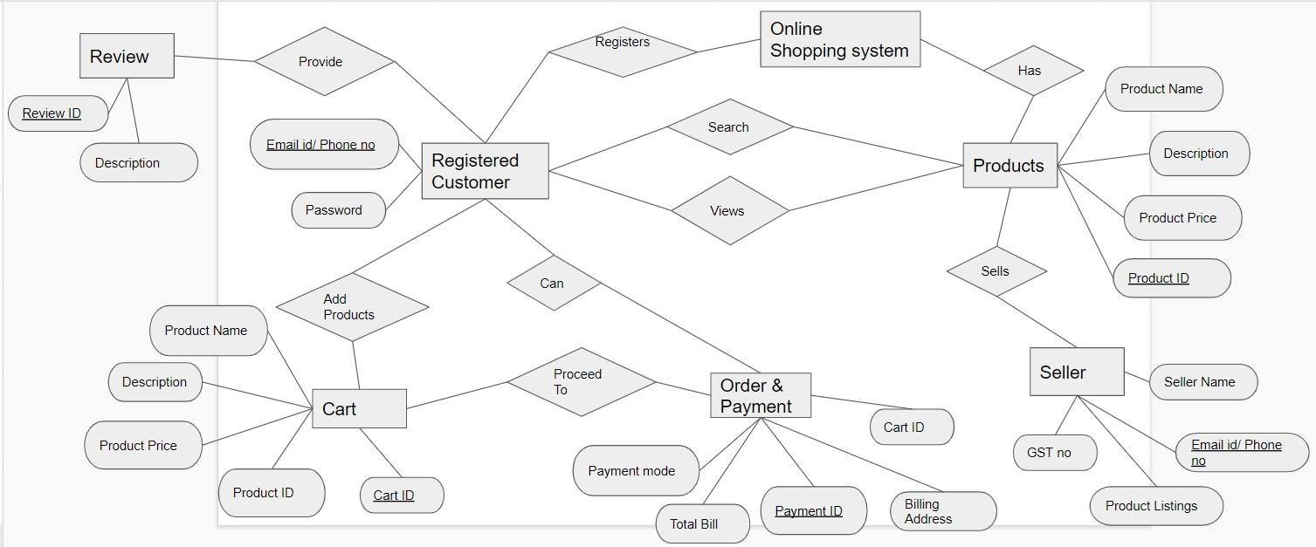
  - ER DIAGRAM:

System Features

User Accounts

Description and Priority
Users from both subsystems- customers and sellers must have an account to conduct transactions on the shopping system. Users without system accounts will only have browsing permissions from the home page and do not have options to purchase or list goods on the system. Customers accounts will hold information about their name, email id or phone number, password. Both users can view and login to their accounts and even edit account details in the future. Seller accounts hold information relevant to the selling organization or individual including name, contact, gst number, pan, licenses and address.
Priority level: High

Stimulus/Response Sequences
In the home page, users can select the signup or login button and type in their credentials for registration or for login respectively. Upon matching the required criteria, the account will either get created and the login page is displayed or the user is logged in to his/her account and the home page is displayed. To edit or view account details, the edit or view buttons may be clicked respectively. To edit details, the user may type in the new details and click on save changes. Upon validating the changes, the edited details are successfully updated.

Functional Requirements
REQ-1: Register
      - User: Customers and sellers
      - Input: In sign up page
        - Customer - enters name, email-id/phone number and password
        - Seller - enters name, email-id/phone number, gst no,
      - Output: Successfully registered, the login page is displayed
      - Alternative flow(s):
        - Incase of repeated/invalid email id or phone number, ask user to re-enter a valid choice

REQ-2: View account details
      - User: Customers and sellers
      - Input: Click ‘view account details’ button in home page
      - Output: Displays account details that were filled by the user at the time of creating account
      - Alternative flow(s) : none REQ-3: Login
      - User: Customers and seller
      - Input: In login page
        - Customer - enters registered username and password
        - Seller - enters registered email-id number and password
      - Output: Successfully logged in, the home page is displayed
      - Alternative flow(s):
        - In case of invalid usename/phone number or a mismatch between user id and password, ask the user to re-enter a valid credential.
REQ-4: Logout
      - User: Customers and sellers
      - Input: Click ‘logout’ button in home page
      - Output: User is logged out of the account, Login page will be displayed
      - Alternative flow(s) : none REQ-5: Edit account details
      - User: Customers and sellers
      - Input: In home page
        - Click button to edit account details
        - Select the detail whose value has to be edited
        - Enter the new details
        - Click on save changes
      - Output: Successfully updated
      - Alternative flow(s):
        - Incase of invalid details, ask the user to re-enter a valid credential

The search facility

Description and Priority
Customers can search for an item from the large catalogue of items in the shopping system by two methods. They can either search for a product using keywords related to the product or search for the product by image. Relevant options are listed in a dropdown of the search bar which upon selection, lists the products related to the keyword searched for
Priority: High

Stimulus/Response Sequences
To search for the product, the customer types in keywords into a search box or pastes an image of the product. This action immediately shows a drop down with the most likely products. The user then clicks on the product he/she wants to view.

Functional Requirements
REQ-1: Search item
      - User: Customers

      - Input: In the home page
        - click on the browse button.
        - type in the keywords related to the item like item name/ brand etc.
      - Output: List of products related to the item searched for
      - Alternative flow(s):
        - Displays:
          - No results for the searched term/keyword
          - Try checking your spelling or use more general terms
REQ-2: View Item
      - User: Customers
      - Input: From the list of items click on an item to view its details
      - Output: Details of the selected item like - price, brand, size, material, quantity, delivery date, images of the item will be displayed, along with the ratings and reviews for that item, and add to cart button
      - Alternative flow(s): none

The shopping cart facility

Description and Priority
Once the customer views and selects an item that he/she wishes to purchase, one must add the item to cart using the add to cart button. The shopping cart contains all the items that the customer intends to buy, there is one shopping cart associated with one user account. The user can browse for an item, add it to cart and continue his/her shopping gracefully and purchase all of them at once.
Priority: high

Stimulus/Response Sequences
To add an item to the shopping cart, the user must click on the add item to cart button in the view item page, and the customer can continue shopping other items. The customer can view all the items in his cart by clicking on the view cart button, upon which a list of all items along with price of individual item, quantity and total cost of the cart is displayed. In this page the customer has the option to remove items from the cart or change the quantity of the products by clicking on the delete item button next to the item or ‘plus’ or ‘minus’ symbols respectively.
From here the customer can proceed to buy all the items in the cart, by clicking on the proceed to buy button or can further continue shopping by going back to the home page by clicking on the continue shopping button.

Functional Requirements

REQ-1: Add item to cart.
      - fUser: Customers
      - Input: In view item page
        - click on the add item to cart button
      - Output: Added item to cart, will remain in the same page
      - Alternative flow(s):

        - Incase of adding an item that is already in the cart, the quantity of that item will be increased by 1 in the cart.
REQ-2: View shopping cart
      - User: Customers
      - Input: present in all pages
        - click on the view cart button
      - Output: List of items that were added to cart is displayed along with item details and total cost
      - Alternative flow(s): Incase the cart is empty, ‘cart empty’ is displayed and the customer has the option to return to home page by clicking on continue shopping
REQ-3: Change items in cart
      - User: Customers
      - Input: In shopping cart page
        - click on delete item button present next to the item to delete the item from the cart
        - to change the quantity of items click on ‘+’ to increase quantity by 1,
or ‘-’ to decrease quantity by 1
      - Output: Changes reflected in the shopping cart page based on activity performed, the item will be removed from the page if it is deleted
      - Alternative flow(s): none REQ-4: Proceed to buy
      - User: Customers
      - Input: In shopping cart page
        - click on proceed to buy button
      - Output: Payment page is displayed
      - Alternative flow(s): none REQ-5: Continue shopping
      - User: Customers
      - Input: In shopping cart page
        - click on continue shopping button
      - Output: home page is displayed
      - Alternative flow(s): none

Payment

Description and Priority
Once the customer proceeds to buy from the cart page, the delivery and payment page is visible where the total cost of all the items in the card is visible and the customer has to fill in the details necessary for delivery to the customer’s desired address and for the payment of items to be ordered. After filling the details the customer has to click on place order to confirm and book the order.

Stimulus/Response Sequences
To buy the items in the cart, the customer has to click on proceed to buy button in the shopping cart page, then the ‘delivery and payment’ page is displayed where the customer has to fill in the delivery address- house number, street address, pincode, city, state and click on delivery to this address, then the payment details like payment

mode- credit/debit card/pay on delivery. In case of credit/debit card enter the card details and cvv number and make the necessary verifications through otp, and click on Pay. On successful payment the place order page is displayed where the customer has to click on the place order button for placing the order confirmly and the items then enter the delivery process. The customer is then redirected to the home page.

Functional Requirements
REQ-1: Delivery details
      - User: Customers
      - Input: In delivery & payment page
        - Enter the delivery address:
          - house number, street address, pincode, city, state
        - Click on deliver to this address
      - Output: the payment page is displayed
      - Alternative flow(s): Incase of invalid address entry, the order is not delivered and is cancelled in the future
REQ-2: Payment details
      - User: Customers
      - Input: In delivery & payment page
        - Enter the payment details:
          - Payment mode:
            - debit/credit card: enter card number, cvv number
            - pay on delivery
        - Click on deliver to this address
      - Output: Payment successful, the place order page is displayed
      - Alternative flow(s): Incase of invalid payment details, the user has to re-enter valid details, unless successful payment the customer cannot place order
REQ-3: Place order
      - User: Customers
      - Input: In place order page
        - Click on place order
      - Output: Order successfully placed, the home page is displayed
      - Alternative flow(s): Incase the user exists the page, order is not placed

Orders and returns

Description and Priority
Orders and returns feature offers order management and flexibility to return orders within certain period of time that is specified by the seller of that item.The customer can view and manage orders that are yet to be delivered to the customer. He/she can cancel the order that is yet to be delivered or return the item that is delivered and get the paid amount back, or view past orders and returns. Also upon successful placing of the order, the customer can track order, i.e the delivery stage- dispatchment, shipment of the item along with the location- city, state in which the item is currently in.
Priority: Medium

Stimulus/Response Sequences

In the home page the customer can click on ‘orders and returns’ button, a list of past and existing orders and returns are displayed. If the customer wants to cancel an existing order that is not yet delivered he/she can click on cancel order in the orders section of the returns and orders page, and if the customer wants to return an item that is delivered, he/she can click on return item and enter the reason for cancelling order or returning an item in the reason box. If the customer wants to track the order that had been placed earlier and yet to be delivered he/ she can click on the track order button of that particular item and the different stages of the delivery of the item will be displayed along with the date, time and location at that time, and current stage of the item.

Functional Requirements
REQ-1: View orders and returns
      - User: Customers
      - Input: In home page
        - Click on orders and returns button
      - Output: the past and existing orders and past returns are displayed
      - Alternative flow(s): none REQ-2: Cancel order
      - User: Customers
      - Input: In orders and returns page
        - Click on cancel order button present next to the order and type in the reason for cancelling
      - Output: the order is successfully cancelled, the orders and returns page remains displayed
      - Alternative flow(s): none REQ-2: Track order
      - User: Customers
      - Input: In orders and returns page
        - Click on track order button present next to the order
      - Output: the tracking information of that order is displayed
      - Alternative flow(s): none REQ-2: Return item
      - User: Customers
      - Input: In orders and returns page
        - Click on return item button present next to the item and type in the reason for returning the item
      - Output: the item is successfully booked for return, the orders and returns page remains displayed
      - Alternative flow(s): none

Other system features
    - Recommendation models: The server is responsible for maintaining the recommendation model. The recommendation model is used to customize the products that are visible to the customer in their home page. These are built using collaborative filtering models.

    - Rate and Review: The rate and review features are available to the client subsystem and are used to build a community of consumers. Each customer has the option to review purchased products and assign ratings or satisfaction levels. The system may choose to terminate products that have low satisfaction ratings.

Seller features

Description and Priority
Sellers can sell their items using the features provided by the system such as easy uploading of the list of items to sell and effective notification system when the order is made by a customer and display history of the sales made in the past
Priority: High

Stimulus/Response Sequences
To upload the listings of the items that the seller wishes to sell, he/she has to click on the upload listing button and enter the details for each item such as name of the product, price, colour, material, quantity, brand. For viewing the current order from the customers he/she has to click on the view of new orders, where the details of the customer like the delivery address and the items booked are visible. To deliver the ordered items to the customers one can click a self delivery option where he/she can deliver to the customer independently, or can click use external delivery and can hire an external delivery system to perform the delivery.

Functional Requirements
REQ-1: Upload listing
      - User: Sellers
      - Input: In home page
        - Click on upload listings and enter details (name of the item, price, material, quantity, colour) of all the items to sell
      - Output: the items successfully uploaded, customers can view these items
      - Alternative flow(s): none REQ-2: View new orders
      - User: Sellers
      - Input: In home page
        - Click on view new orders
      - Output: displays the orders for his/her items from the customers
      - Alternative flow(s): none REQ-3: Deliver to customer
      - User: Sellers
      - Input: In view new orders page
        - Click on deliver to customer and select either
          - deliver independently (self delivery)
          - external delivery (hire external delivery agency)
      - Output: Item added to delivery, items undergo delivery process
      - Alternative flow(s): none

Other Nonfunctional Requirements

Performance Requirements
An online shopping service has many levels of organization and its overall performance is a confluence of factors that affect all these different levels
- Information system: The infrastructure and organization of the information system can crucially affect performance in the following ways
  - average response time of web page
  - failure rate
  - average web page creation time
  - site maintenance costs
In order to maintain an acceptable speed at the maximum number of requests allowed from a particular customer, any number of users must be able to access the system at any time. A smooth UI/UX is a necessity for all ecommerce applications. While a visually appealing design is essential, image optimization and other techniques can be implemented to ensure that the site is not very heavy. Real-time technologies equip online retailers with tools to keep up with the ever-evolving search ecosystem. Flexible goal setting, third-party data integration and real-time optimization offers a systematic solution to many ongoing challenges.
- Logistics:
  - product availability
  - average delivery time
  - quality of delivery
  - liability failure rate
  - inventory turnover
To overcome issues related to the logistics, the service has to ensure that the right product should be available at the right time and adequate quality. Some services may hire a 3PL to ensure this. A 3PL is a third party logistics service. Many online shopping services outsource their logistic operations and choose to invest their resources in other areas. However, many e-stores prefer to employ their own resources in logistic planning and implementation for better control over distribution.
- Sales activity:
  - acquisition cost
  - acquisition cost per first customer
  - brand awareness
There are various measures that can be taken to ensure that sales activity is improved.
- Build engagement
- limit spending
- develop partnerships
The above points illustrate some of the important performance criteria in terms of profitability analysis
- Market and customer
  - number of unique customers
  - average visit frequency
  - number of first buyers
  - average order value
- Sales process
  - fulfilment cost
  - personnel cost

  - marketing cost
  - return on sales
  - total turnover
The above points illustrate key performance criterias in terms of structural analysis. On analyzing the current or immediate state of the service, some important criteria to consider while evaluating performance is:
- sales growth
- order number growth
- visit frequency growth.
- market share growth
- complaint rate
On a non-technical front, customer satisfaction with the service itself is intrinsically linked with general satisfaction with products, delivery and website experiences. All sellers have a sellers account where they can monitor their account health. sellers are liable for product quality and are measured based on order of
- customer feedback rating (target: 3.5 stars or more)
- negative feedback rate (target: 1% or less)
- cancellation rate (target: 5% or less)
- reschedule rate (target: 5% or less)
It is essential for sellers to maintain acceptable service levels to be able to continue their market on the online service.

Safety Requirements
There are a wide range of concerns that arise wherever online transactions are performed- especially with money transactions and address records. One of the most common risks of online shopping is online shopping. Stealing one’s personal information to make illegitimate purchases, phishing and keylogging are common ways used to steal identity.
Another common risk is credit card frauds. Customers may be redirected to the malicious user’s site during payment- that is made to look similar to the legitimate payment gateway and cost them money and may even have their credit card numbers stolen.
Malwares and Adwares commonly plague many websites. The risk is even higher with online shopping websites as scammers may easily acquire sensitive information entered by the user. Simply visiting the website makes the malware attack the user system.
To ensure user safety, measures must be taken from both the user side as well as the shopping system’s side. From the user side, the user must never divulge any personal information except during bill payment. Users must be careful not to fall prey to phishing by verifying that mails being sent from the service are in fact, authentic. Users must be wary of ads and ensure that appropriate antivirus softwares has been installed in one’s system.
The shopping system itself has to take concrete measures to ensure that customer;s can trust the service being provided to them. SIte seals on web sites are visual indicators that the website is safe and secure. Acquiring SSLs certificates are mandatory as this ensures the user that the communication channel is encrypted.

Security Requirements
To ensure secure transfer of data, the system must use secure sockets in all transactions that include any confidential customer information. The system may choose to automatically log out all customers after a period of inactivity and verify by confirmation all the transactions with the customer’s web browser. The system will ensure that cookies and all temporary storage do not

hold any sensitive information. The customer’s web browser must never display a customer’s password or credit card details. The system’s back-end servers must never display a customer’s password and these servers must only be accessible to authenticated administrators. These databases must be encrypted and within the company's perimeter.
The service can ensure user identity authentication using two-step verification procedures. Further, the system can ensure that any additional security risks experienced by the users can be reported to the system immediately.

Software Quality Attributes
Adaptability is of primary importance to both types of users of the system. It should be able to easily cater to the needs of sellers and customers and be able to add additional features and provide support as demanded- especially in case of system vulnerability. As an online shopping system, it must define product availability by defining the targeted audience be it global users or a more restricted user space. It is also important to ensure that sellers are able to deliver products to the regions promised by the service. Due to user sensitive information being required, ensuring that money transactions are not error prone is vital. Utmost correctness is to be expected in ensuring that money is refund money in case of returns, offers on products are appropriately deducted from the selling price, delivery services have minimal error and that warehouses function properly. The system should also be highly flexible with servers that are equipped to be able to accommodate large flow of traffic. The system must be interoperable and must work without any compromise in performance and quality in both mobile applications as well as web applications. should be built with modularity so that additional features can be added and removed easily without changing too much of the original structure- this also allows reusability. The reliability of the overall program depends on the reliability of the separate components. The main pillar of reliability of the system is the backup of the database which needs to be continuously maintained and updated to reflect the most recent changes. Testing the system can be done on various fronts. Unit testing can be done by taking atomic components of the system, isolating it from the remainder of the code, and determining whether it behaves as expected. Program units are combined and tested as groups in multiple ways. Integration testing can expose problems with the interfaces among program components before trouble occurs in real- world program execution. Validation testing focuses on user visible actions and user recognizable output from the system and is said to be successful when software functions in a manner that can be reasonably expected by the customer.

Business Rules
Given the presence of two subsystems for the customers and sellers, the two types of users have different levels of privileges - including functionalities.
Some of the functionalities common to the two subsystems are- registration, login, viewing account details and editing account details. Some functionalities specific to Seller subsystems are seller’s sales details, and uploading items to the inventory. Customers also have browsing features, cart features, delivery details, payment options, cancellation, review options and many more.

Other Requirements
A robust commercial backend that delineates customer and seller information is necessary. A general management backend with inventory and general system requirements is also required.

Authorization from payment services is needed for customers to be able to make payments through payment gateways. A defined privacy policy, SSL certification and two-step verification through external mail or phone number is also necessary to ensure no breach in both user data and system data.

Appendix A: Glossary
Some key terms used repeatedly throughout the document are
- Customer subsystem: A subsystem within the online shopping system support for customers
- Seller subsystem: A subsystem within the online shopping system support for sellers
- GST: Goods and services tax applicable to all products
- PAN: permanent account number
- Seller listing: Sellers will add their product listings to the system
- Turnover: net sales generated by the system
- avg response time: average time taken to respond to a user request
- failure rate: frequency of failure of an individual component
- liability failure rate: amount of product or service defects that hold the system liable
- inventory turnover: ratio that measures the number of times inventory is sold or consumed in a given time period
- acquisition cost: Customer Acquisition Cost is the cost of winning a customer to purchase a product/service
- brand awareness: marketing term that describes the degree of consumer
recognition of a product by its name
- fulfilment cost: costs associated with receiving and storing products along with processing orders from handling to shipping.
- market share growth: growth strategies to broaden market share

Appendix B: Field Layouts
Fields with information required to Login

FIELD | LENGTH | DATA TYPE | Description | Is Mandatory
email-id | 20 | Alphanumeric |  | N
Username | 25 | String |  | Y
Password | 9 | Alphanumeric |  | Y

Fields with information required for Payment

FIELD | LENGTH | DATA TYPE | Description | Is Mandatory
payment-mode | 3 | Numeric | Has three modes Credit card, debit card and Cash on delivery each having a different value | Y
card-number | 16 | Numeric |  | N
CVV | 3 | Numeric |  | N

Appendix C: Requirement Traceability Matrix

Sl. No | Requirement ID | Brief Description of Requirement | Architecture Reference | Design Reference | Expected Result | Actual Result | Status
1. | Browse | To view product | System | Customer | Provides the | Provides the | Pass
 |  | information | features 5.2 | Use Case | user with | user with
 |  |  |  | Diagram | appropriate | appropriate
 |  |  |  | 4.1 | product  information | product  information
2. | Payment | Enable Customers | System | Customer | Provide the | Provide the | Pass
 | Mechanism | to make payments | features 5.2 | Use Case | user with | user with
 |  |  |  | Diagram | convenient | convenient
 |  |  |  | 4.1 | and safe | and safe
 |  |  |  |  | payment  mechanism | payment  mechanism

